Measurement on vibrations of a rotor.(rotordynamics)
Model: (figure from journal of vibrations and acoustics 140(1),august 2017,Liahao Yang et al.)
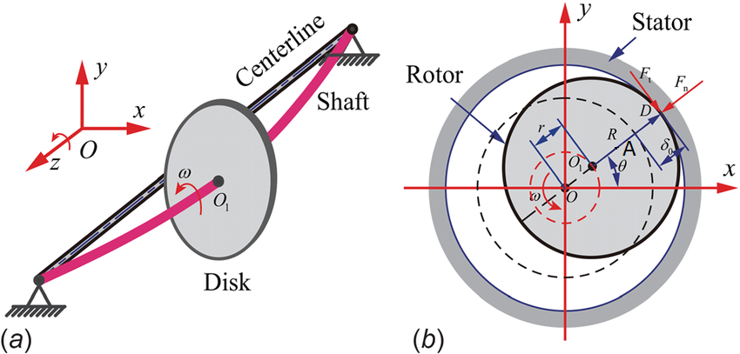

Line of axis: O
Centre of the rotor: O₁
Centre of gravity :A
The system rotates round O: OO₁ = s and O₁A = e
Centrifugalforce: mrω² = m(s+e)ω²
Counteracting force:ks
What would this counteracting force stand for? In other words, give a physical argument that describes ks.
The system is in equilibrium so
m(s+e)ω² =ks
(mω²-k)s + mω² e =0
Or s =( -mω² /mω² –k) e
We can rearrange $s=\frac{ω^{2}}{\frac{k}{m}-ω^{2}} e$
We can see that when ω reaches the value $\sqrt{\frac{k}{m}}$ the vector s becomes infinitly large. This is what is called the critical speed. Above this pulsation s becomes negative. At this rotation speed a rotor will balance itself.
This model is not complete but only an approximation. What are the other forces that have an influence on the unbalance?

1)First we measure the vibrations of a rotor at different speeds and with different unbalancing forces by changing the massdistribution of the rotor. To change the massdistribution we use bolts and screws.
mass(g) | motorspeed (Hz) | Acc(g)1 | Acc(g)2 | Acc(g)3 | acc(g)mean | speed(mm/s)1 | speed2 | speed3
1 | 30
 | 40
 | 50
 | 60
2 | 30
 | 40
 | 50
 | 60
3 | 30
 | 40
 | 50
 | 60

Make plots and calculate correlations of these plots.
2)Take measurements of the vibrations when changing the alignment of the electromotor. Changing the alignement has to be done by turning the screws placed on only one side of the construction.
situation 1 | speed(Hz) | acceleration(mm/s²)
 | 20
 | 30
 | 40
 | 50
 | 60

situation 2 | speed(Hz) | acceleration(mm/s²)
 | 20
 | 30
 | 40
 | 50
 | 60

situation 3 | speed(Hz) | acceleration(mm/s²)
 | 20
 | 30
 | 40
 | 50
 | 60

